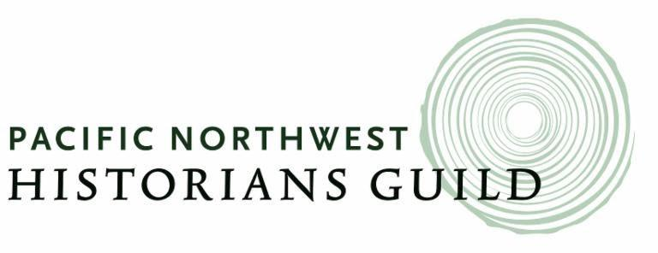

***Challenging History***

**CALL FOR CONFERENCE PROPOSALS**

**DUE: MAY 30, 2025**

**The Pacific Northwest Historians Guild invites proposals for presentations at its biennial conference on Saturday, October 11, 2025 at the downtown Seattle Public Library.**

This year’s conference title is "Challenging History.” Join us to share your experiences of meeting challenges faced in reporting, teaching or preserving history, or in telling stories of those who have faced challenges in our region’s history.

Potential areas of focus might include:

* The impact of modern technology on historical research and study.
* Meeting challenges in the classroom – truth, fiction and historical analysis.
* Making history through collaborative group efforts
* Challenges facing local historical groups
* Ethical challenges when shaping the collective memory
* Preserving and archiving history

There is no charge for participating in or attending this conference. Anyone wishing to share research on Pacific Northwest history may submit a proposal for consideration. Past conferences have included presentations from public historians, teachers, students and independent scholars, museum professionals and volunteers, as well as scholars affiliated with colleges and universities.

Proposals for panels or roundtables are also welcome. The organizer should include a panel abstract along with summaries of each presentation and bios of all participants. Workshops or interactive presentations are encouraged. Scholarships are also available to undergraduate and graduate students for travel to the conference.

Please send all proposals (individual, panel or roundtable) to [pacificnwhistoriansguild@gmail.com](mailto:pacificnwhistoriansguild@gmail.com). Include a summary of your proposed presentation in no more than 250 words and a bio of no more than 100 words for each participant. Please include in the email subject line your last name and the title of your presentation. The beginning of your summary should state what kind of presentation you are proposing (e.g. solo presentation, panel discussion).

**All materials must be received no later than May 30, 2025.**

**Questions? Contact us at** **pacificnwhistoriansguild@gmail.com**

The Pacific Northwest Historians Guild brings together people concerned with the study and dissemination of regional history. Founded in November 1980, the Guild fosters teaching and appreciation of Northwest history and promotes communication among regional historians.

For more information visit: <http://www.pnwhistorians.org/guild/>

This free conference is made possible by members of the Pacific Northwest Historians Guild. Program participants are encouraged to join the Guild, which will help ensure that this and other free activities will continue. To become a member, visit [https://pnwhistorians.org/guild/index.php/membership/](https://pnwhistorians.org/guild/index.php/membership/%20)

.

THANKS TO THE FOLLOWING SPONSORS FOR THEIR GENEROUS SUPPORT

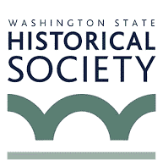 [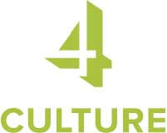](https://www.4culture.org/) 